LAB
REPORT

COURSE NO. : ICT 4256
COURSE TITLE : COMPUTER NETWORKING LAB

PREPARED BY  Mehrin Farzana  ID:2101013  Session: 2021-2022 | SUPERVISED BY  Md. Toukir Ahmed  Lecturer  Department of ICT, BDU

 | BANGABANDHU SHEIKH MUJIBUR RAHMAN DIGITAL UNIVERSITY  (BDU)
Report No: 01
Report Title: Basics of Cisco Packet Tracer.
_____________________________________________________________________

Objectives:
● To learn how to create a basic network in PT
● To learn how to configure a network topology using command mode

Discussion:
A Network simulation tool helps to understand visually how networks work. Network topology is the geometric representation of the relationship of all the links connecting the devices or nodes. Network topology represents in two ways one is physical topology that defines the way in which a network is physically laid out and another one is logical topology that defines how data flows through the network. In this paper we have discussed the basics of Cisco packet tracer, how to design a peer to peer network and provide interfacing and simulation between end points using packet tracer software.

Methodology of my project:
● See the basics of CPT
● Create a basic peer to peer Network.
● Configuration of the Network Nodes.
● Choose the Statistics.
● Run the Simulation.
● Analysis of the Results.
2
Working Procedure:
To implement this practical following peer to peer network is required to be configured. After configuring the given network, a packet should be ping from any one machine to another.

Cisco Packet Tracer

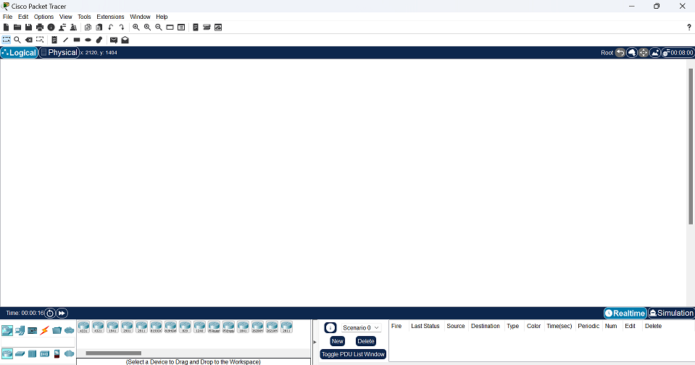
Figure 1.1: Cisco Packet Tracer

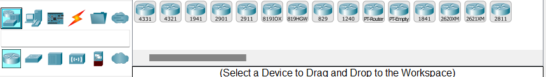
Figure 1.2: Network components with different types in CPT

- Establishing a peer to peer network

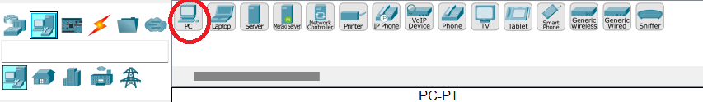
Figure 1.3: Choosing Desktop PC from end devices in CPT

3
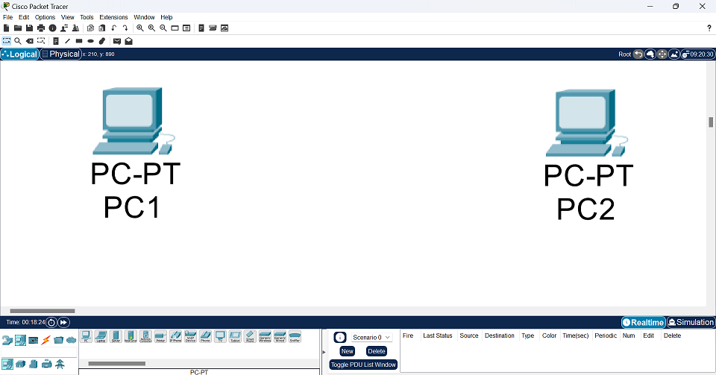
Figure 1.4: Taking two desktop PCs in CPT

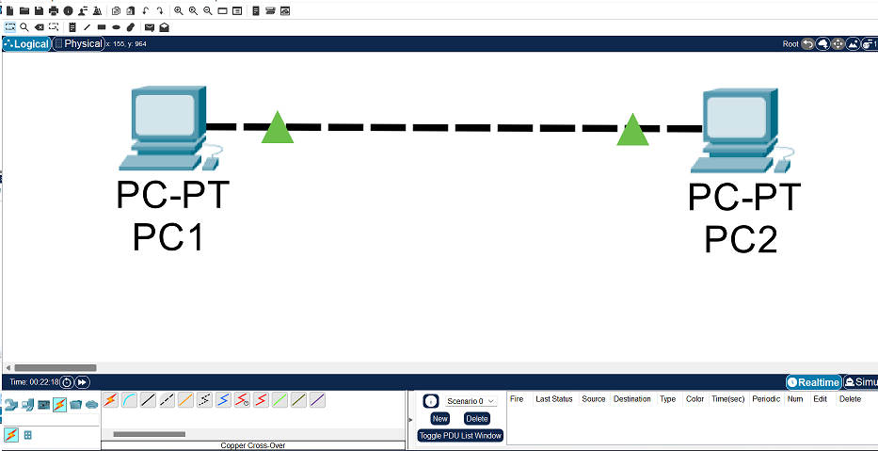
Figure 1.5: Two desktop PCs connected by copper cross-over cables by Fast Ethernet ports in CPT

- Configure PC1, PC2 with following IP addresses

Host | IP Address
PC1 | 10.10.10.1
PC2 | 10.10.10.2

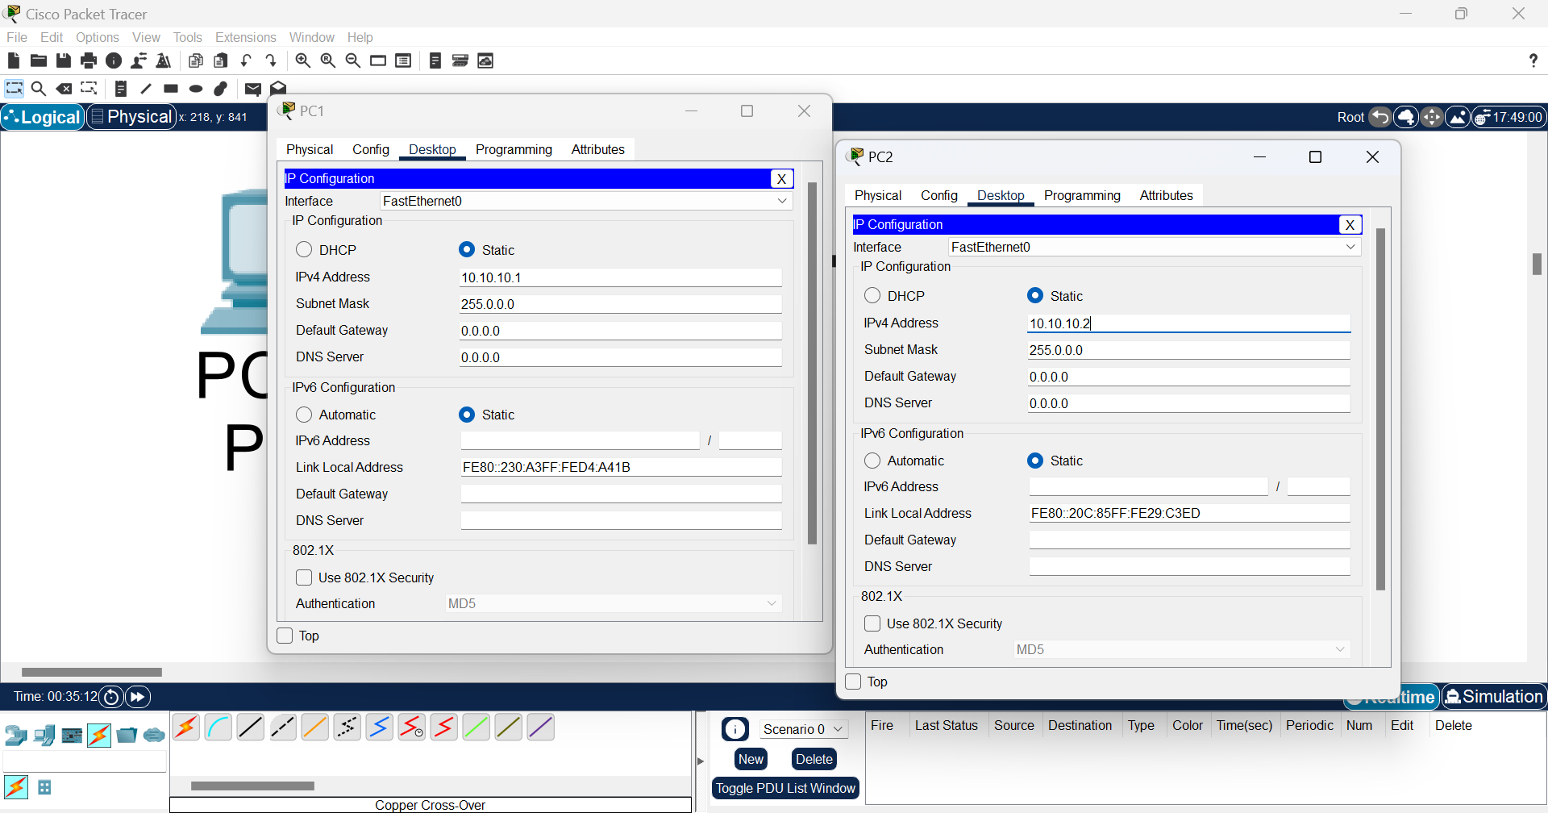
Figure 1.6: Assigning IP addresses to PC1 and PC2 in CPT
4
- Using the ping command to verify the connection from PC1 to PC2

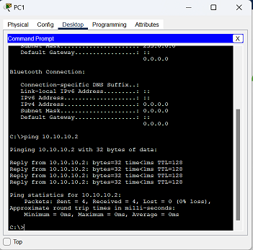
Figure 1.7: ping command to verify the connection from PC0 to PC1.

- Simulation

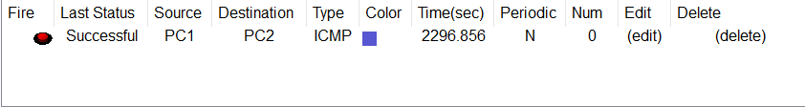
Figure 1.8: Successful Packets travel across PCs.

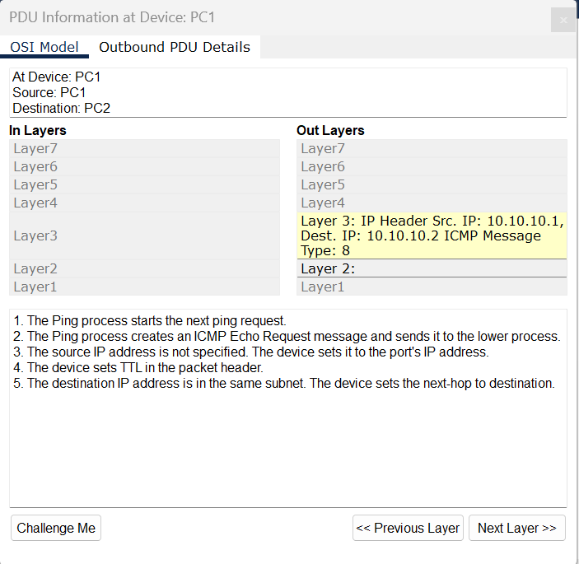
Figure 1.9: Protocol data unit at PC1

5
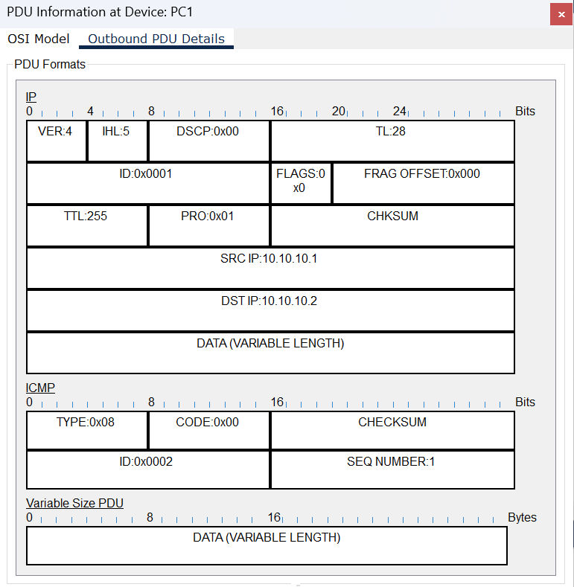
Figure 1.10: Outbound PDU (Protocol data unit) at PC1

Conclusion:
This network represents the Introduction with Network Topology using Cisco Packet Tracer. Here we have also compared the Check the connection from one PC to another using the ping command.

6
Report No: 02
Report Title: Star topology using Hub.
_____________________________________________________________________

Objective:
● To learn how a hub works

Discussion:
Hub is an unintelligent,as it has no memory, network-connecting device usually used as a center in a star topology and always works in half-duplex mode and is only capable of broadcasting-transmission of data. It operates in the physical layer of OSI model.

Methodology of my project:
● Create a star topology using hub.
● Configuration of the Network Nodes.
● Choose the Statistics.
● Run the Simulation.
● Analysis of the Results.

Working Procedure:
To implement this practical following network topology is required to be configured using the commands learned in previous practical. After configuring the given network, a packet should be ping from any one machine to another.

7
Star topology using a hub
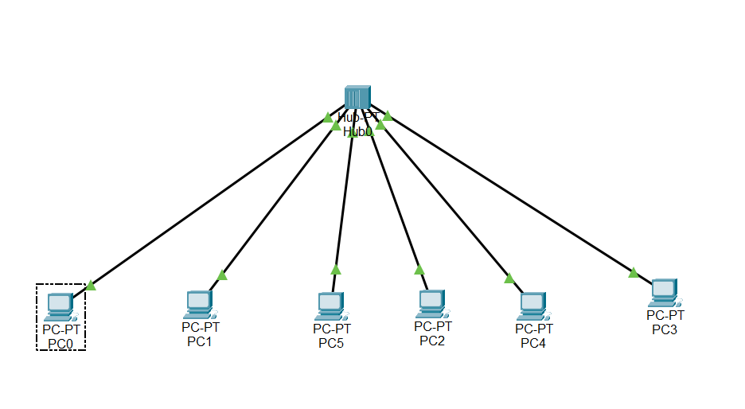
Figure 2.1: Star topology using a hub in CPT

- IP configuration on PCs
Click PC->Desktop->IP Configuration . On each PC assign these IP addresses:

PC0: IP address: 10.10.10.1

PC1: IP address: 10.10.10.2

PC2: IP address: 10.10.10.3

PC3: IP address: 10.10.10.4

PC4: IP address: 10.10.10.5

PC5: IP address: 10.10.10.6

- Connection test across PCs
In each PC’s Command Prompt write “ping<space>IP address of one other PC”.If connection is there, four replies will be gotten.
Need to check for connections with every other PCs.
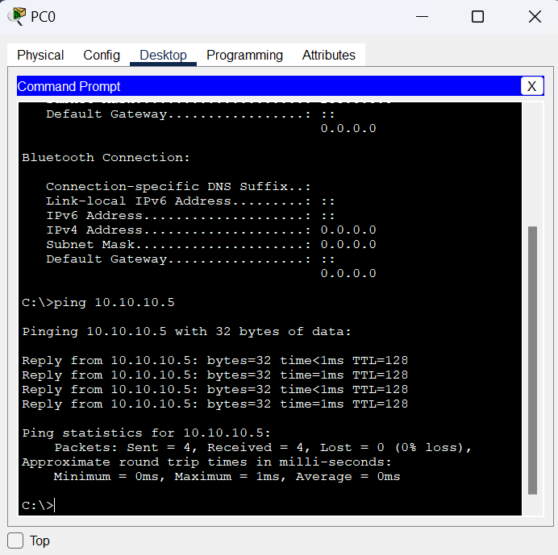
Figure 2.2: ping command verifying the connection from PC0 to PC1.
8
- Working of a hub

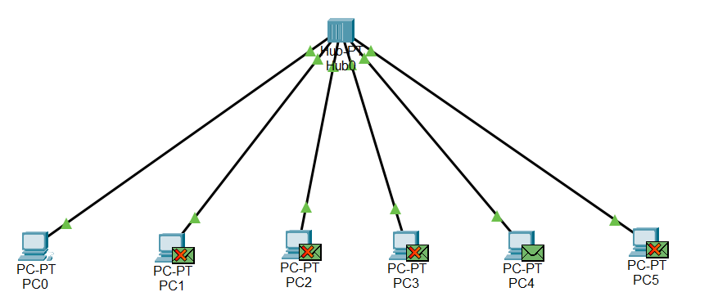
Figure 2.3: Hub sending data from PC0 to PC4.

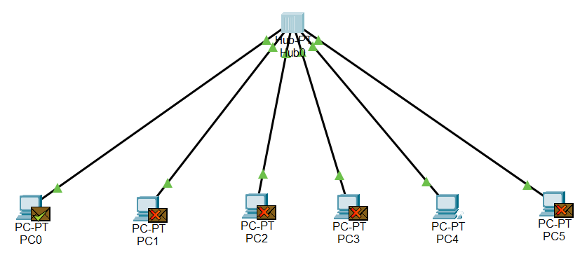
Figure 2.4: Hub sending reply from PC4 to PC0.

- Simulation

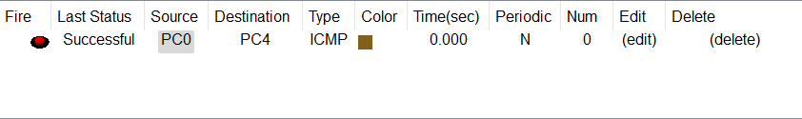
Figure 2.5: Successful Packets travel across PCs.

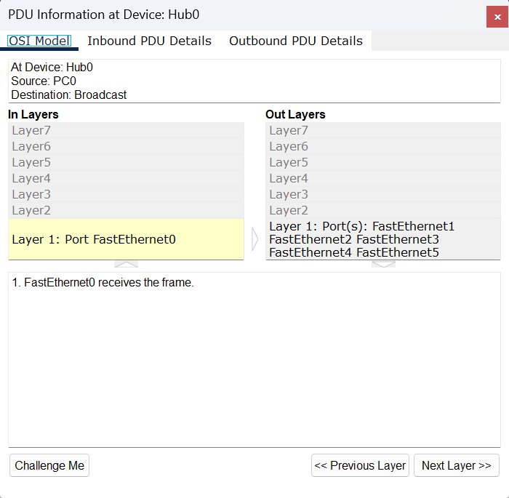
Figure 2.6: Protocol data unit at Hub

9
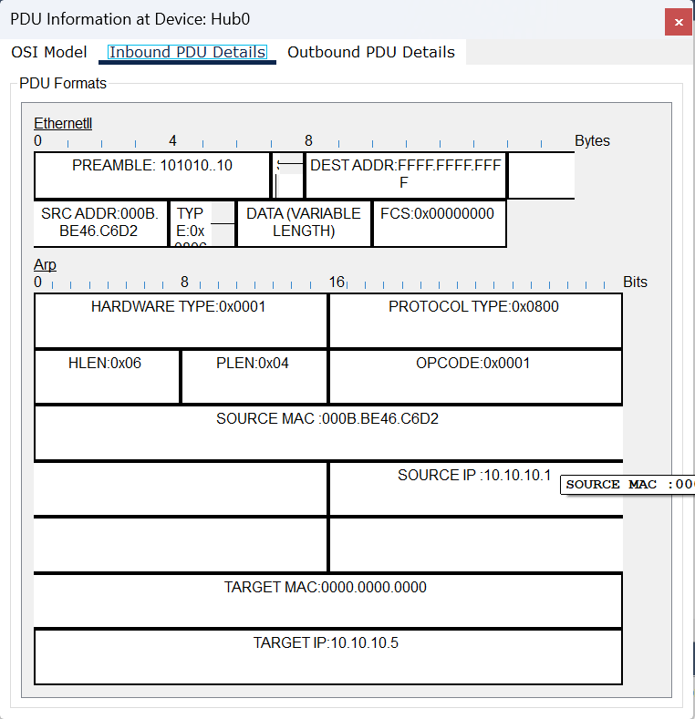
Figure 2.7: Inbound PDU (Protocol data unit) at Hub

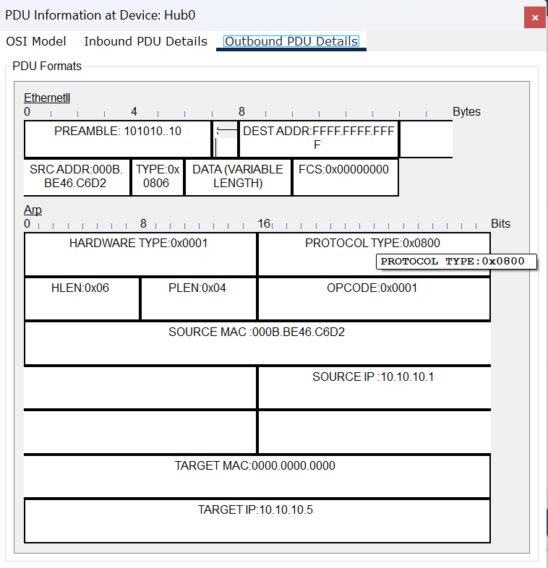
Figure 2.8: Outbound PDU (Protocol data unit) at Hub

Conclusion:
Hub is an unintelligent network-connecting device with no memory that always transmits data by broadcasting.

10
Report No: 03
Report Title: Star topology using Switch.
_____________________________________________________________________

Objective:
● To learn how a switch works
● See how switches are different from a hub

Discussion:
Switch, unlike hubs, is an intelligent, as it has a memory, network-connecting device usually used as a center in a star topology and always works in full-duplex mode and is capable of broadcasting, uni-casting and multi-casting-transmission of data. It operates in the data link layer of OSI model.

Methodology of my project:
● Create a star topology using a switch.
● Configuration of the Network Nodes.
● Choose the Statistics.
● Run the Simulation.
● Analysis of the Results.

Working Procedure:
To implement this practical following network topology is required to be configured using the commands learned in previous practical. After configuring the given network, a packet should be ping from any one machine to another
11
Star topology using a switch
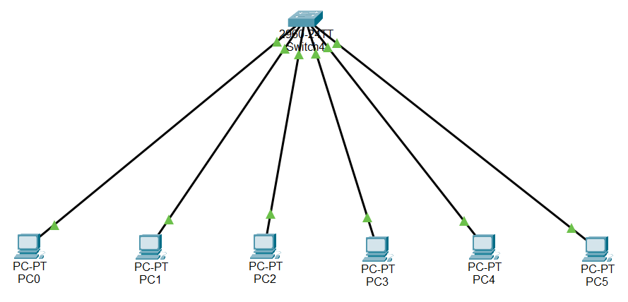
Figure 3.1: Star topology using a switch in CPT

- IP configuration on PCs
Click PC->Desktop->IP Configuration . On each PC assign these IP addresses:

PC0: IP address: 10.10.10.1

PC1: IP address: 10.10.10.2

PC2: IP address: 10.10.10.3

PC3: IP address: 10.10.10.4

PC4: IP address: 10.10.10.5

PC5: IP address: 10.10.10.6

- Connection test across PCs
In each PC’s Command Prompt write “ping<space>IP address of one other PC”
If connection is there, then four replies will be gotten.
Need to check for connections with every other PCs.

12
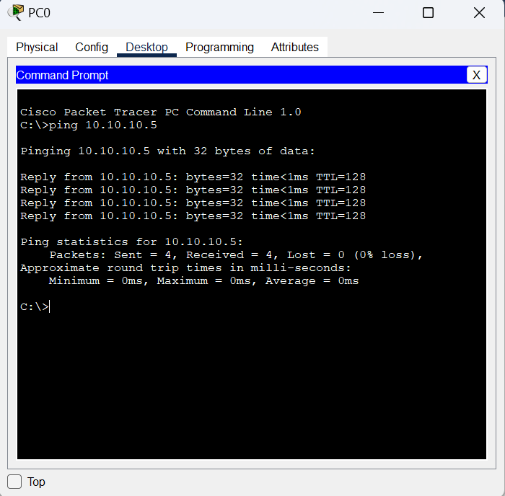
Figure 3.2: ping command verifying the connection from PC0 to PC4.

- Result

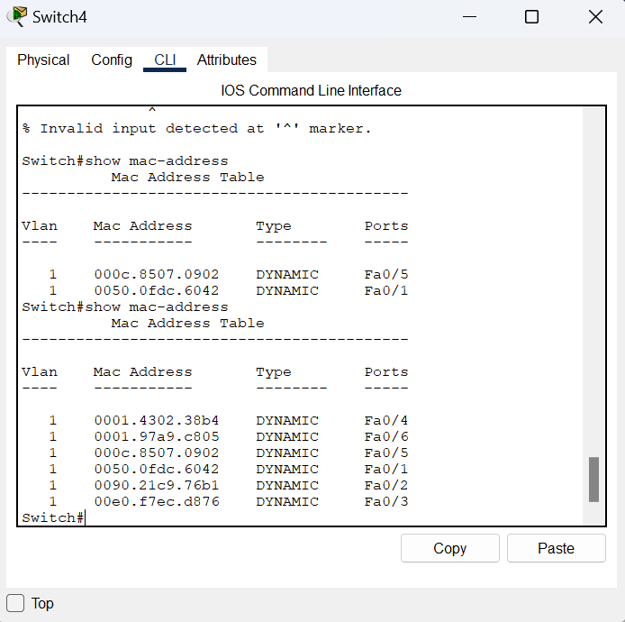
Figure 3.3: Switch storing MAC addresses of PCs.

- Working of a switch

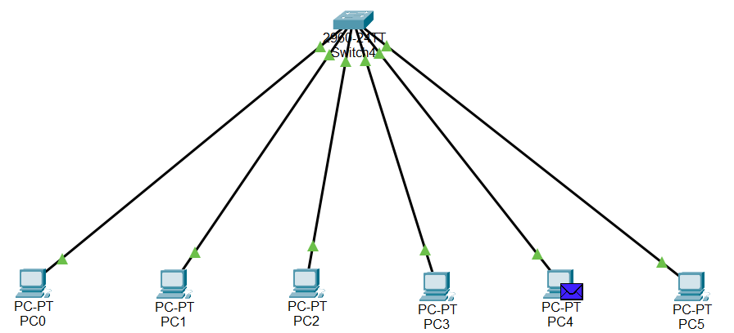
Figure 3.4: Switch sending data from PC0 to PC4.

13
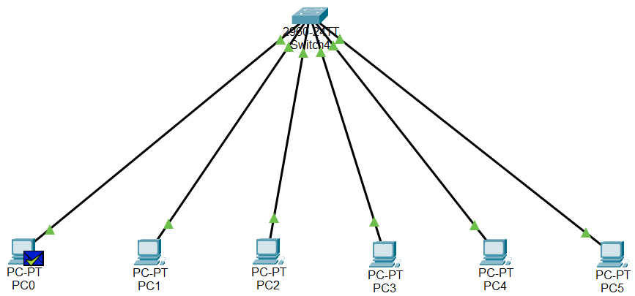
Figure 3.5: Switch sending reply from PC4 to PC0.

- Simulation

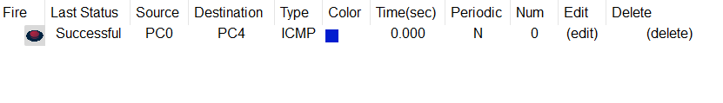
Figure 3.6: Successful Packets travel across PCs.

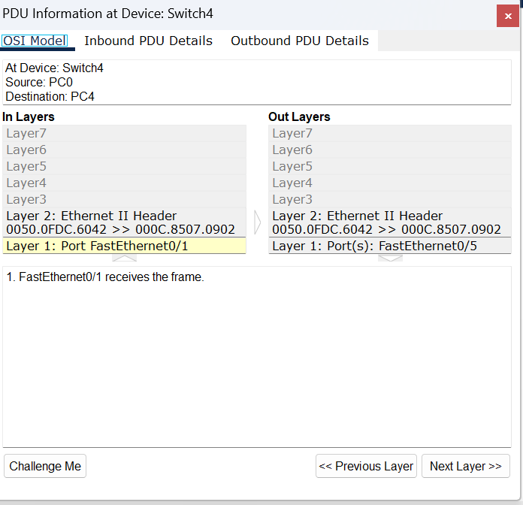
Figure 3.7: Protocol data unit at Switch

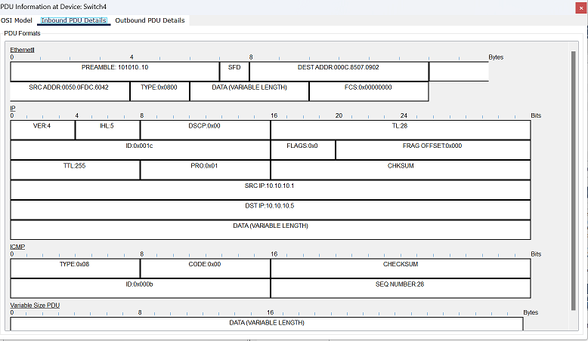
Figure 3.8: Inbound PDU (Protocol data unit) at Switch

14
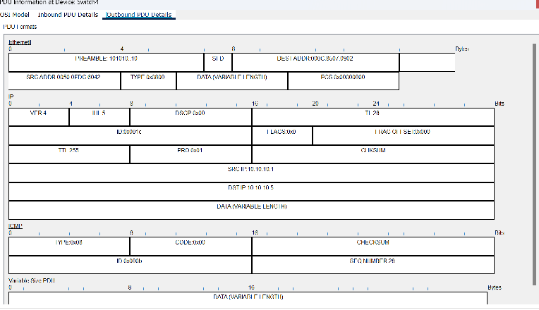
Figure 3.9: Outbound PDU (Protocol data unit) at Switch

Conclusion:
Switch is an intelligent network-connecting device with a memory that can operate Uni-casting.

Difference between Hub and Switch;
Hub | VS | Switch
- Sends data to every device connected to it, excluding the data-sender.  - Operates in physical layer of OSI (Open Systems Interconnection) model.  - Does broadcast type transmission only.  - Data transmission time is comparatively more.  - Cheap.  - Less ports; only 4 to 12 ports. |  | - Sends data to only which it is sent to.  - Operates in data link layer of OSI model.  - Can do uni-cast type transmission.  - Data transmission is faster.  - Comparatively pricier.  - More ports; 24 to 48 ports.

15

